Michelle Chen Einstein’s Dice
11/19/17 Final Paper Outline
Looking For Luck: Copenhagen Quantum Concepts Behind Interaction-Free Measurements
There are many essential principles of quantum mechanics that are used to construct
interaction-free measurements. Proposed in 1993 by Avshalom C. Elitzur and Lev Vaidman, the
concept of interaction-free measurement allows one to detect an object’s location without any
particle interacting with the object, unlike classical methods of measurement. Though
interaction-free measurement is able to detect the existence of an unstable system without
disturbing its internal quantum state, collapse, or the moment when multiple unpredictable
possibilities represented by a quantum entity’s wave function collapse and force the entity into a
single possibility upon measurement, still occurs. This demonstrates a new aspect to the
classical Copenhagen theory of quantum mechanics, proving that physical interaction is not
necessary for collapse to happen and a possibility to be selected from an uncertain array of
unpredictable possibilities. While interaction-free measurement introduces this new element of
interaction-free collapse to the Copenhagen theory, certain pillars of the Copenhagen theory such
as non-locality and the nature of wave functions and collapses are still especially prominent and
useful in explaining interaction-free measurement. Many experiments exist that illuminate
these quantum principles behind interaction-free measurement as well as the element of chance
behind this type of measurement’s success and efficiency. This sets it apart from classical, non-
quantum-mechanical methods of measurement and prevents this type of measurement from
being used outside of certain specialized situations. However, using the quantum Zeno effect,
physical devices that allow interaction-free measurement can be built so that the probability of
success for each interaction-free measurement increases. This makes more efficient and accurate
measurements possible using this useful technique, which has fascinating implications for fields
such as medicine, imaging quantum objects, and the demonstration of quantum effects on the
macroscopic scale. Copenhagen ideas and interaction-free measurement greatly inform each
other and by thinking about each through the lens of the other our understandings of quantum
mechanics and interaction-free measurement’s processes can improve.
In Copenhagen thinking, non-locality is highly suggested and plays a large role in
distinguishing the concepts of classical quantum mechanics from classical physics. This concept
is also a strong construction behind interaction-free measurement as all interaction-free
measurements are implied to be non-local. Locality is the concept that events cannot have
instantaneous effects at a distance or effects that propagate faster than light but through
interaction-free measurement, one can instantaneously know the position or path of a particle and collapse
the wave function, or the superposition of all the possible outcomes, without interacting with the particle
locally. Interaction-free measurement thus violates locality just as the Copenhagen quantum
interpretation does, since information can be gained despite a complete lack of local interaction. In this
way, it is possible to confirm the existence of an object in a given region of space beyond a doubt even if
no particles or photons, the most basic quantum particle of light, bounce off it. While classical methods of
measurement require the contact of least one particle for observation, such as a photon bouncing off it to
the eye or a detector, the Copenhagen theory’s violation of locality lends support to quantum interaction-
free measurement.
One example of the important concept of nonlocality in interaction-free measurements is
the Renninger negative-result thought experiment. A single photon is emitted and hits a fifty-
percent beam splitter where there is an equal chance of traveling along either path. One of the
paths is shorter than the other, there are detectors at the ends of both paths, and only the results
of the first and closest detector are measured. If the photon is detected by the detector on the
shorter path, it is not an interaction-free measurement as the detector interacts with the photon.
However, if the photon is not detected by the first detector after the expected period of time
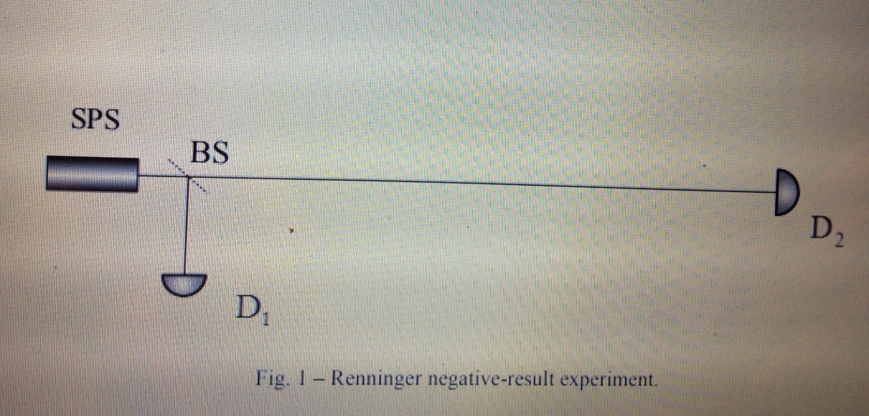
Cardoso, A., Cordobil, J.L., and Croca, J.R. (2015), “Interaction-Free Measurements: A Complex Nonlinear Explanation,” University of Lisbon, pp. 2, http://arxiv.org/ftp/arxiv/papers/1501/1501.01993.pdf.

within which it might hit the first detector, the probability wave collapses and the location of the
photon is certain to be heading along the second path toward the other detector no matter how
much further away the second detector is. Since there is a collapse of the wave function without
any detection, it is called a “negative” measurement. There is a fifty-percent likelihood that the
measurement will succeed in being interaction-free as in this thought experiment, the detectors
are assumed to be a hundred percent efficient. In this example, non-locality plays a prominent
role and lens for the concept of interaction-free measurement as certain information is gathered
about the photon’s path without any local interaction at all. In this case, the photon is shown to
have traveled along the longer path without a doubt when the first detector measures nothing
within the time period for a photon to be detected if it had traveled along the shorter path. The
collapse of the probability wave occurs in the moment when either nothing or something is
detected by the first detector. In fifty percent of the cases, where the photon travels the longer
path, simply measuring the closer detector’s lack of a measurement will ascertain the path of the
photon. The essence of interaction-free measurement is the fact that collapse can occur and a
possibility be selected even without local interaction with the measured particle, which
contradicts classical physics but is supported by the Copenhagen theory’s own non-locality. This
demonstrates the importance of non-locality in constructing and understanding interaction-free
measurement.
Another aspect of Copenhagen quantum mechanics that aids the process of
understanding interaction-free measurement is the nature of wave functions and collapse. In the
Elitzur-Vaidman bomb-testing thought experiment, a light source emits one photon at a time
toward a Mach-Zehnder interferometer, where it hits a beam splitter and recombines at a second
beam splitter that sends the photon to one of two detectors. The two paths are of equal length and
one detector shows constructive interference while the other shows destructive interference,
which means that normally it will never detect a photon. When an object, or a bomb that goes
off upon classical observation through bouncing a single particle off it, is placed in one path,
there is up to a fifty percent chance the photon does not hit the object and continues so there is no
interference at the second splitter. There, the photon now makes a random choice, so that it is a
possibility that the photon will travel to the detector that had previously never received a photon
when there was no bomb in one of the paths. The interaction-free measurement is made during
the occasional times the photon goes to the detector that usually detects destructive interference
as it is only possible for that to happen with an object in a path. It is interaction-free because the
photon can only go one path and never touched the object in this situation yet determined its
presence, or otherwise found a bomb without it going off. Interaction-free measurement is
shown through this experiment to use the same definitions of wave functions and collapse as the
Copenhagen theory. In Copenhagen theory, a wave function is the concept of the quantum state
as a mathematical object that represents the states of physical systems,where an unobserved
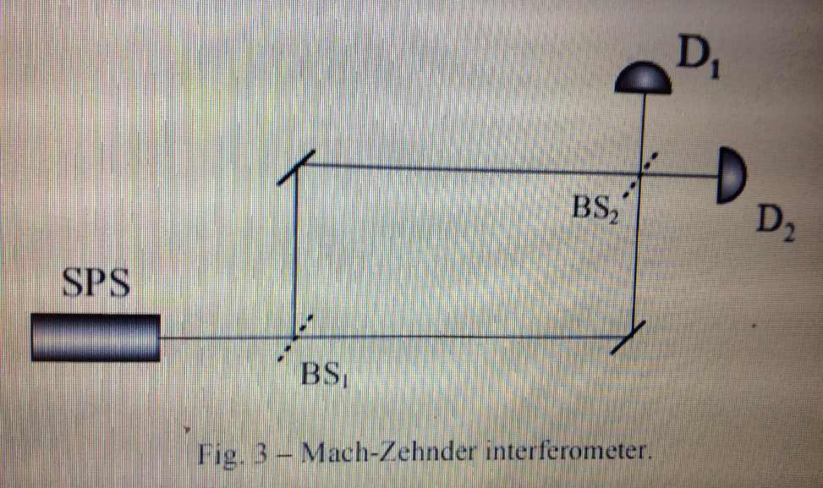
Cardoso, A., Cordobil, J.L., and Croca, J.R. (2015), “Interaction-Free Measurements: A Complex Nonlinear Explanation,” University of Lisbon, pp. 2, http://arxiv.org/ftp/arxiv/papers/1501/1501.01993.pdf.

quantum entity exists in a superposition of all the possible states permitted by its wave function.
This overlap of possibilities only exists until a measurement is made that is capable of
distinguishing these states, at which point the wave function collapses and the entity is forced
into a single state. As a result, Copenhagen quantum mechanics legitimizes interaction-free
measurement as a form of measurement in interaction-free measurement’s ability to cause
collapse. Additionally, because of interaction-free measurement’s unique ability to collapse a
wave function without any physical or local interaction, it adds a previously undemonstrated
dimension to the Copenhagen concept of collapse, proving that the selection of a single
possibility is not dependent on the physical interaction that defines classical measurement
techniques. Overall, interaction-free measurement has both roots in Copenhagen wave function
theories and influence over the evolution of Copenhagen interpretations of collapse.
Beyond thought experiments, interaction-free measurement is highly useful when its
efficiency is improved using the quantum Zeno effect. Experimentally, there is an inherent
element of chance behind interaction-free measurement: only up to fifty percent of
measurements in a real-world Mach-Zehnder interferometer can be made interaction-free without
the quantum Zeno effect. However, the usefulness of modified interaction-free measurement
has been realized. This was originally demonstrated in the quantum Zeno thought experiment
using devices that rotate the polarization of a horizontally polarized photon 15 degrees, where
after passing through six the photon’s polarization changes from horizontal to vertical and is then
absorbed by the final horizontal polarizer, never arriving at the detector. If a horizontal polarizer
is placed after each rotator, the chance that the photon will become absorbed in the first polarizer
is very small, and if it passes it returns to horizontal polarization as that is the only possible state
for light that passes a horizontal polarizer. The process repeats, with the probability of the photon
being transmitted all the way through increasing by increasing the number of rotators and
decreasing the angles of each rotator accordingly: with an infinite number of stages, the photon
would always get through, and the rotation would have been completely inhibited. By
repeatedly not measuring a quantum system, its time evolution can be halted, and with an infinite
number of rotators and polarizers, the state of the photon remains the same indefinitely. An
efficient experimental system has been created for interaction-free measurement that optimizes
the quantum Zeno effect. A polarizing beam splitter and polarization rotator are used along with
mirrors that can be rapidly switched on and off for a horizontally polarized photon to pass
through the system for a few cycles. When an object is placed in the vertical polarization path, it
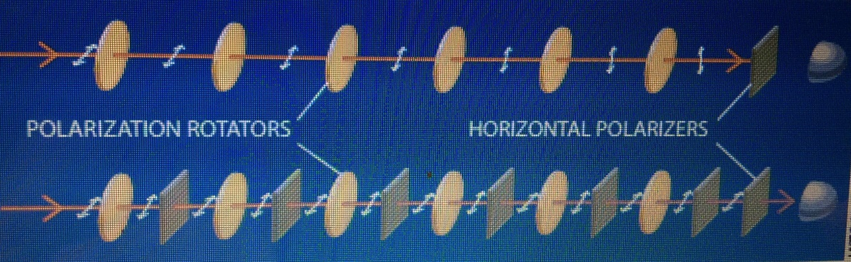
is similar to the insertion of polarizers after each rotator in the quantum Zeno thought
Kwiat, P., Weinfurter, H., and Zeilinger, A. (November 1996), “Quantum Seeing in the Dark,” Scientific American, Vol. 275 (No. 5), pp. 73, http://jstor.org/stable/24993449.
experiment, where the chance of the photon entering the vertical polarization path and hitting the
object is low and the photon typically becomes reset to its initial horizontal polarization. While
without the object the leaving photon is vertical, the presence of an object is shown when the
leaving photon is horizontal. By using more cycles, the probability that the photon is absorbed by
the object can be made as small as possible, and it is more likely for the interaction-free
measurement to be performed correctly. When interaction-free measurement works, it works
completely by confirming an object’s path or existence without any doubt. Because of the
quantum Zeno effect greatly increasing the probability of success, interaction-free measurement
could potentially be useful for photography without light exposure, medical imaging without x-
ray exposure, imaging ultra-cold atom clouds, and create quantum objects at the macroscopic
scale. In this way, interaction-free measurement brings the Copenhagen quantum mechanical
concepts of non-locality, wave functions, and collapse to practical use in the macroscopic world.
Once thought to be impossible, interaction-free measurement is a method that has both
practical and theoretical impacts. Principles from the Copenhagen theory of quantum mechanics
that are used to construct interaction-free measurement include non-locality and the nature of
wave functions, but interaction-free measurement also uniquely informs Copenhagen notions of
collapse by demonstrating that collapse can occur without local or physical interaction. The
Renninger negative-result and Elitzur-Vaidman bomb-testing thought experiment especially
illuminate interaction-free measurement’s solid grounding in these principles. While these
thought experiments demonstrate how chance is a factor behind the efficiency and success of
interaction-free measurement as opposed to classical measurement, the quantum Zeno effect can
greatly increase the probability of a successful interaction-free measurement. Through
experimental devices that utilize the quantum Zeno effect, interaction-free measurement can be
developed to the point where it could have many efficient uses and advantages over classical
methods of measurement such as its complete accuracy when used successfully and its versatility
in different scientific fields. Overall, interaction-free measurement’s basis in ideas of
Copenhagen quantum theory allows us to clarify other aspects of the Copenhagen premise such
as the nature of collapse. Ultimately, the impact of the quantum Zeno effect on the efficiency of
interaction-free measurement allows us to bring the most theoretical aspects of Copenhagen
quantum mechanics into the experimental world.

Bibliography

Albert, D. Z. (1994, May). Bohm’s Alternative to Quantum Mechanics. Scientific American, Vol.
270 (No. 5), pp. 58-67. Retrieved October 15, 2017 from http://www.jstor.org/stable/
24942695.

Cardoso, A., Cordovil, J. L., and Croca, J. R. (2015). “Interaction-Free Measurements: A
Complex Nonlinear Explanation.” University of Lisbon. Retrieved November 20, 2017
from https://arxiv.org/ftp/arxiv/papers/1501/1501.01993.pdf.

Elitzur, A.C. and Vaidman L. (1993). “Quantum Mechanical Interaction-Free Measurements.”
School of Physics and Astronomy Tel-Aviv University. Retrieved November 20, 2017
from https://arxiv.org/pdf/hep-th/9305002.pdf.

Horgan, J. (1992, July). Quantum Philosophy. Scientific American, Vol. 267 (No. 1), pp. 94-105.
Retrieved October 15, 2017 from http://www.jstor.org/stable/24939143.

Kwiat, P., Weinfurter, H., and Zeilinger, A. (1996, November). “Quantum Seeing in the Dark.”
Scientific American, Vol. 275 (No. 5), pp. 72-78. Retrieved November 20, 2017 from
http://www.jstor.org/stable/24993449.

Shimony, A. (1988, January). The Reality of the Quantum World. Scientific American, Vol. 258
(No. 1), pp. 46-53. Retrieved October 15, 2017 from http://www.jstor.org/stable/
24988945.

Vaidman, L. (1994). “On the Paradoxial Aspects of New Quantum Experiments.” PSA:
Proceedings of the Biennial Meeting of the Philosophy of Science Association, The
University of Chicago Press on Behalf of the Philosophy of Science Association, Vol.
1994 (Volume One: Contributed Papers), pp. 211-217. Retrieved December 4, 2017 from
http://www.jstor.org/stable/193026.

Elitzur, A.C. and Vaidman, L. (1993), “Quantum Mechanical Interaction-Free Measurements,” School of Physics and Astronomy Tel-Aviv University, pp. 6, https://arxiv.org/pdf/hep-th/9305002.pdf.
Elitzur, A.C. and Vaidman, L., “Quantum Mechanical Interaction-Free Measurements,” pp. 11.
Horgan, J. (1992, July), “Quantum Philosophy,” Scientific American, Vol. 267 (No. 1), pp. 97, http://www.jstor.org/stable/24939143.
Kwiat, P., Weinfurter, H., and Zeilinger, A. (November 1996), “Quantum Seeing in the Dark,” Scientific American, Vol. 275 (No. 5), pp. 73, http://jstor.org/stable/24993449.
Shimony, A. (1988, January), “The Reality of the Quantum World,” Scientific American, Vol. 258 (No. 1), pp. 48, www.jstor.org/stable/24988945.
Cardoso, A., Cordobil, J.L., and Croca, J.R. (2015), “Interaction-Free Measurements: A Complex Nonlinear Explanation,” University of Lisbon, pp. 2, http://arxiv.org/ftp/arxiv/papers/1501/1501.01993.pdf.
Kwiat, P., Weinfurter, H., and Zeilinger, A., “Quantum Seeing in the Dark,” pp. 72.
Cardoso, A., Cordobil, J.L., and Croca, J.R., “Interaction-Free Measurements: A Complex Nonlinear Explanation,” pp. 2.
Ibid.
Cardoso, A., Cordobil, J.L., and Croca, J.R., “Interaction-Free Measurements: A Complex Nonlinear Explanation,” pp. 4-5.
Vaidman, L. (1994), “On the Paradoxial Aspects of New Quantum Experiments,” PSA: Proceedings of the Biennial Meeting of the Philosophy of Science Association, The University of Chicago Press on Behalf of the Philosophy of Science Association, Vol. 1994 (Volume One: Contributed Papers), pp. 212. http://www.jstor.org/stable/193026.
Ibid.
Kwiat, P., Weinfurter, H., and Zeilinger, A., “Quantum Seeing in the Dark,” pp. 73-74.
Albert, D.Z. (1994, May), “Bohm’s Alternative to Quantum Mechanics,” Scientific American, Vol. 270 (No. 5), pp. 58-67, www.jstor.org/stable/24942695.
Horgan, J. (1992, July), “Quantum Philosophy,” Scientific American, Vol. 267 (No. 1), pp. 97, http://www.jstor.org/stable/24939143.
Kwiat, P., Weinfurter, H., and Zeilinger, A., “Quantum Seeing in the Dark,” pp. 75.
Ibid., pp. 76.
Kwiat, P., Weinfurter, H., and Zeilinger, A., “Quantum Seeing in the Dark,” pp. 77.
Ibid., 74.
Ibid., 77-78.

