An exploration of a poem in simple code: by using technology to delineate evocative language, I hope to subvert expectations of what technology can contribute to creative writing. Readers of poetry often don't see the many drafts and word selections behind a finished piece of creative writing, especially in poetry, which may be oversimplified. In this case, I decided to create a novice input code that reveals many of my choices, broad ideas, and unfiltered writing that went into the more traditional, polished poem of the output. I consider this experimental because I haven't been able to find a similar project out there that utilizes poetry in both the input and output, and that puts as much emphasis on the act of transformation. Just as "double-time" connects the disparate ideas of sound, fruit, and passion, I hope the readers are inspired to see themselves/very human emotions reflected in this poem, and to be curious about its alternate possibilities, laid out in the piece itself as a record of writerly intention/destroyed intentions.
​
double-time (an experience in Java)
Input:
1 public class fruitTime{
2
3 public static void main(String[] args){
4
5 String time = "Every second";
6 String discountTime = "months";
7 String setting = "city";
8 String city = "bowls";
9 String cityScape = "highways and streets";
10 String season = "summer";
11 String love = "sour";
12 String iAteIt = "from the stem";
13 String isSweet = "we are reminded";
14 String goodFruit = "mango";
15 String discountFruit = "squeezed limes";
16 String hunger = "bowls";
17 String somethingUnstable = "static";
18 String heaviness = "Hudson fog";
19 String overRipeThoughts = "knife";
20 String hurts = "indents";
21 String unsettlingBiology = "fist and bone";
22 String drops = "births";
23 String birthed = "dropped";
24 String sorrow = "mother";
25 String lives = "frequencies";
26 String tooFast = "these days";
27 String dirt = "compost";
28 String inTheSky = "on the ground";
29 String pregnancy = "bear fruit";
30 String souls = "flowers";
31 String bug = "cricket";
32 String myLeg = "her shoulder";
33 String chomp = "fruit";
34 String back = "antenna";
35 String enormous = "analog";
36 String life = "baby";
37 String sound = "radio";
38 String body = "chest";
39 String myRibs = "the wiring";
40 String bodyOfWater = "river";
41 String someLover = "you";
42 String drip = "sink";
43 String juice = "an awl";
44 String sexyTimesOrNot = "the handle";
45 String beginning = "root";
46 String isIt = "rise";
47 String justASnack = "sweet";
48 String goneDoubleTime = "."
49
50 System.out.println(time + " we are reminded");
51 System.out.println("of " + goodFruit + "es. In one,");
52 System.out.println("she sits on " + somethingUnstable + ",");
53 System.out.println();
54 System.out.println(love + ", plucked too soon");
55 System.out.println(iAteIt + ".");
56 System.out.println();
57 System.out.println("In another");
58 System.out.println("your " + overRipeThoughts + " " + hurts);
59 System.out.println("overripe skin");
60 System.out.println();
61 System.out.println("and cannot peel,");
62 System.out.println("metal turned");
63 System.out.println();
64 System.out.println(unsettlingBiology + ".");
65 System.out.println("in the " + setting + " there are craters,");
66 System.out.println(discountFruit);
67 System.out.println();
68 System.out.println(hunger + " within " + hunger);
69 System.out.println("by old " + cityScape + ".");
70 System.out.println();
71 System.out.println("That " + season + " when");
72 System.out.println(someLover + " split a " + goodFruit);
73 System.out.println("and found " + heaviness + " inside");
74 System.out.println();
75 System.out.println("or another life where");
76 System.out.println("she " + drops + " a " + goodFruit);
77 System.out.println();
78 System.out.println("as patch of warm");
79 System.out.println("soil and not");
80 System.out.println(sorrow + ".");
81 System.out.println();
82 System.out.println(tooFast + " the frequencies");
83 System.out.println("of pits and " + chomp + " align");
84 System.out.println();
85 System.out.println("when " + birthed + ".");
86 System.out.println("It takes " + discountTime);
87 System.out.println("for " + dirt);
88 System.out.println();
89 System.out.println("to gather in waves");
90 System.out.println(inTheSky);
91 System.out.println();
92 System.out.println("where " + someLover + " massage");
93 System.out.println(souls + " for they may");
94 System.out.println(pregnancy + ".");
95 System.out.println();
96 System.out.println("Though your " + sorrow);
97 System.out.println("broke a " + bug + "'s " + back);
98 System.out.println();
99 System.out.println("when it climbed");
100 System.out.println(myLeg + ".");
101 System.out.println("The amount of sugar");
102 System.out.println();
103 System.out.println("in mango " + enormous + ".");
104 System.out.println(season + " " + life);
105 System.out.println();
106 System.out.println("is the first to find");
107 System.out.println("the " + sound + " channels");
108 System.out.println("inside my " + body + ",");
109 System.out.println();
110 System.out.println("flicks");
111 System.out.println(myRibs);
112 System.out.println();
113 System.out.println("into a " + bodyOfWater + ".");
114 System.out.println("Another time");
115 System.out.println(someLover + " " + drip + " " + juice);
116 System.out.println();
117 System.out.println("into the " + beginning);
118 System.out.println("of my sound");
119 System.out.println();
120 System.out.println("and " + isIt);
121 System.out.println(sexyTimesOrNot);
122 System.out.println(justASnack + goneDoubleTime);
123 }
124}

Output:
 ----jGRASP exec: java fruitTime
▪Every second we are reminded
▪of mangoes. In one,
▪she sits on static,
▪
▪sour, plucked too soon
▪from the stem.
▪
▪In another
▪your knife indents
▪overripe skin
▪
▪and cannot peel,
▪metal turned
▪
▪fist and bone.
▪in the city there are craters,
▪squeezed limes
▪
▪bowls within bowls
▪by old highways and streets.
▪
▪That summer when
▪you split a mango
▪and found Hudson fog inside
▪
▪or another life where
▪she births a mango
▪
▪as patch of warm
▪soil and not
▪mother.
▪
▪these days the frequencies
▪of pits and fruit align
▪
▪when dropped.
▪It takes months
▪for compost
▪
▪to gather in waves
▪on the ground
▪
▪where you massage
▪flowers for they may
▪bear fruit.
▪
▪Though your mother
▪broke a cricket's antenna
▪
▪when it climbed
▪her shoulder.
▪The amount of sugar
▪
▪in mango analog.
▪summer baby
▪
▪is the first to find
▪the radio channels
▪inside my chest,
▪
▪flicks
▪the wiring
▪
▪into a river.
▪Another time
▪you sink an awl
▪
▪into the root
▪of my sound
▪
▪and rise
▪the handle up
▪sweet.
▪
 ----jGRASP: operation complete.

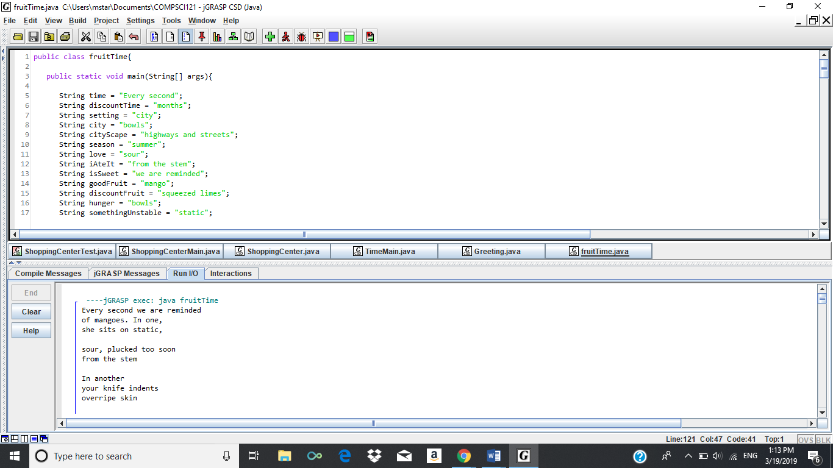
Example

